Name: ______________________ Date: ________________ Period:__________
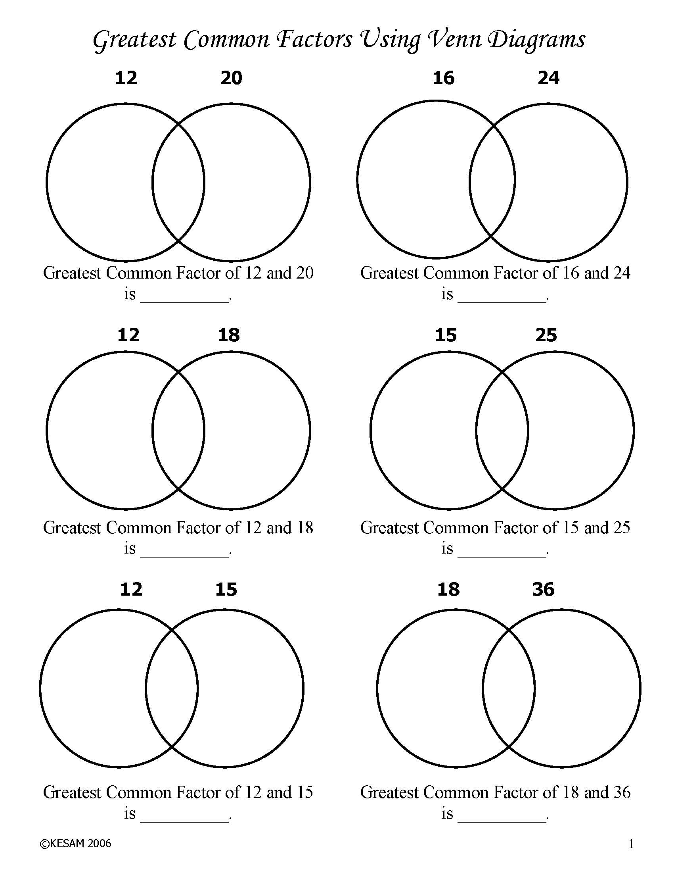

http://kesammath.com/downloads/greatest-common-factors-using-venn-diagrams/

Least Common Multiple Notes
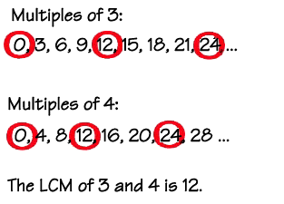

Find the least common multiple for:

- 80 and 4

- 60 and 10

- 54 and 5

- 12 and 24

